**My Process for implementing a newsletter email sign-up option:**

I wanted to implement a form for email newsletter sign up in my website. To do so, I started by adding in the html code for the newsletter container. I want the newsletter field to be toggled by a button, therefore I added a “toggle” ID/class to the button which will then be styled with CSS and javascript will manage the functionality side of it:

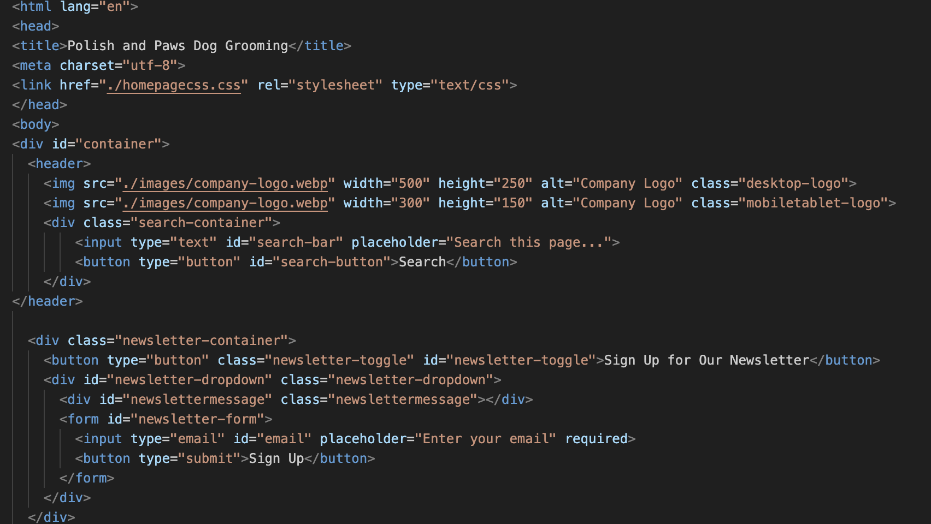

I then used CSS to style elements of the container: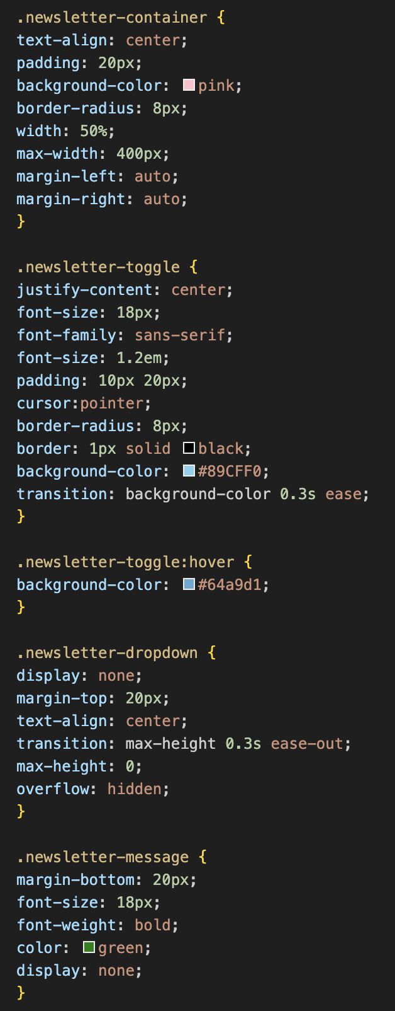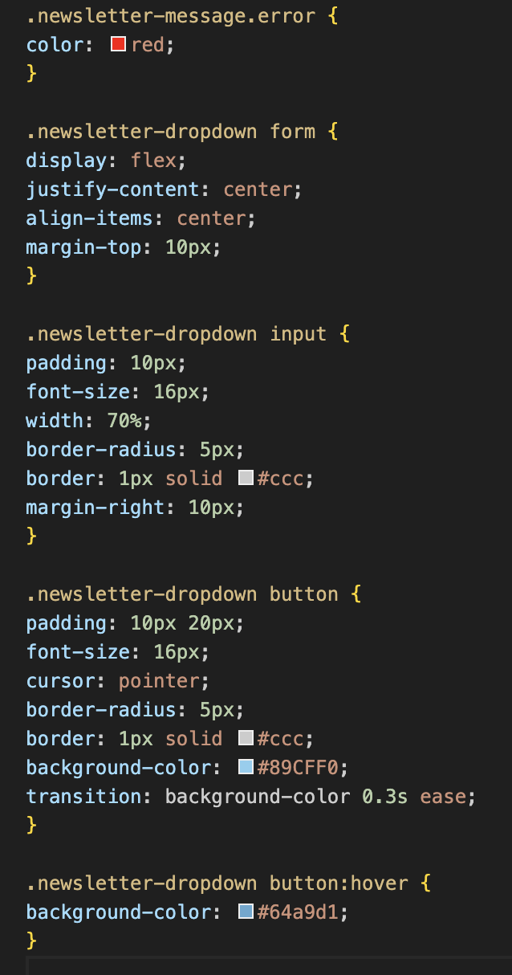

For the Javascript side of this form, I began by retrieving the elements in the HTML using “getElementByID”: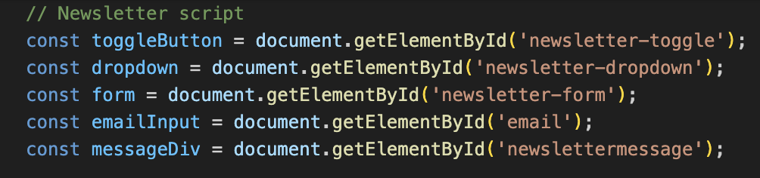

I then added the click event for the dropdown toggle: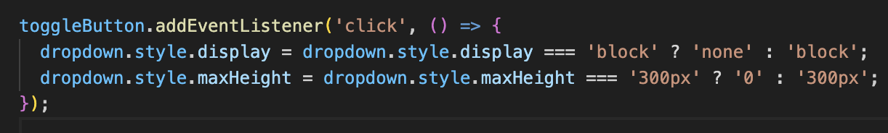

Following this, I added the code that would handle the form’s submission. I prevented default behavior (such as page refresh) to handle the form’s validation. I then added the code to retrieve the email and trim it. The code then adds an argument to state if the email field is empty, an error message will appear and the code will stop.

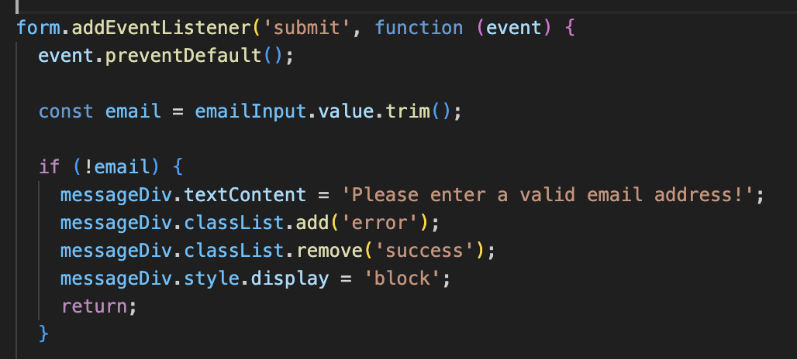

The below code was then added to use a regex to validate the email entered. If the email entered is invalid, an error message will appear.

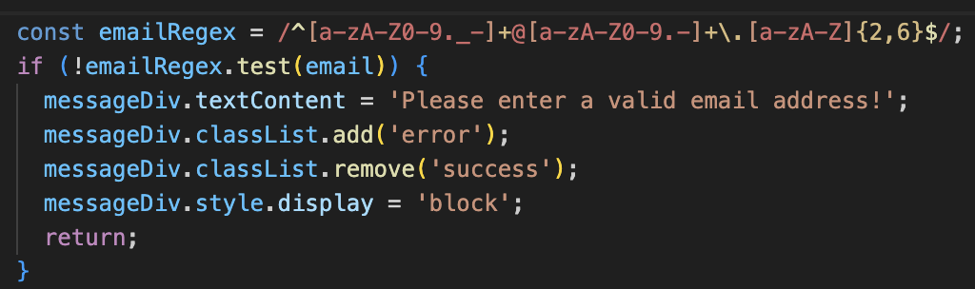

Finally, code was added to ensure that a success message displays if the email entered was valid.

It also styles the message classes using CSS accordingly.

“emailInput.value= ‘’;” then clears the field to prepare for the next submission.

